Nereid DMS Presentation
Table of Contents
Intro 2
Intended Customer Base 2
Features 2
Technologies 2
Servers/Software 2
Features in detail 3
Documents and Folders 3
SharePoint Containers 5
DMS Document Library 5
Template Sink Document Library 6
Scanner Sink Document Library 7
Templates 8
Base Features 8
Barcode in Template 11
Conditional Document Blocks 12

Intro
Microsoft Dynamics CRM out of the box focuses on Sales, Marketing, and Service (help desk) sectors, but with its proprietary (.NET based) framework it can be customized to meet many different demands. CRM however lacks entity-associated document management which can be compensated by using SharePoint Foundation document management facilities. Our solution ties up both systems leveraging shared domain-controlled security giving rich set of document managing features to CRM.

Intended Customer Base
- Banks
- Financial companies
- Governments
- Real estate
- Medical institutions

Features
- Seamless CRM integration
- Intuitive user interface
- Multiple CRM entities supported
- Basic support of text/document file types including PDF
- Extended support of Microsoft Word 2007, 2010
- Word document templates
- Template and template document structure management
- Conditional Word document blocks
- Bidirectional document relation via barcodes
- Domain-controlled security transparent for end user
- jQuery-powered UI
- UI localization

Technologies
- .NET
- ASP.NET
- jQuery
- MS CRM SDK
- MS SharePoint SDK
- MS SQL

Servers/Software
- MS Dynamics CRM 4.0
- MS SharePoint 2010 Server (Foundation is sufficient thus installation costs can be reduced)
- MS SQL Server
- MS Office 2007/2010
- Optional: Document scanning solutions with barcode recognition and SharePoint importing features for bidirectional document binding (eg. Kofax Express http://www.kofax.com/journal/index.php/tag/bar-code-indexing/)

Features in detail

Documents and Folders
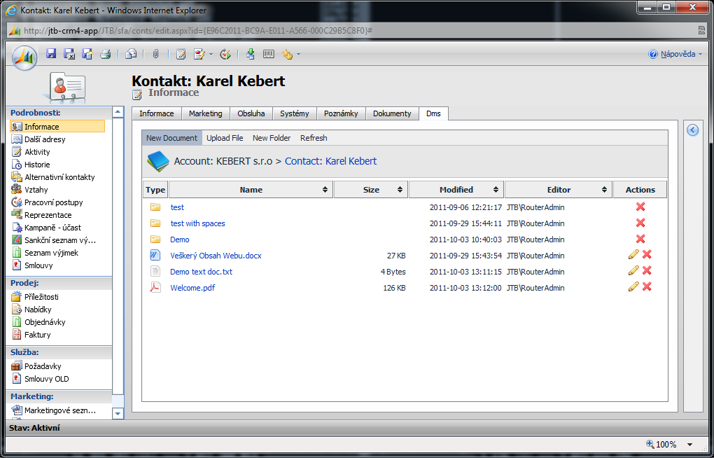
Picture 1: Main view
- Document/folders list
- File types indicated by corresponding icon
- Essential file information (size, modified by, modified time)
- Basic document management actions (edit, delete)
- Intuitive jQuery-powered UI
- Document list sorting by one or multiple columns
- Menu containing document structure commands
- “New Document” submenu contains entity-associated document types

Picture 2: Navigation bar

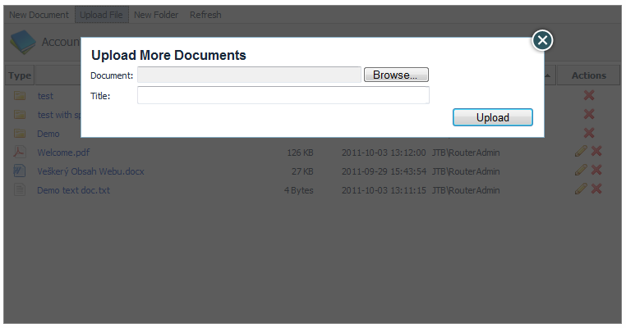
Picture 3: Upload document dialog

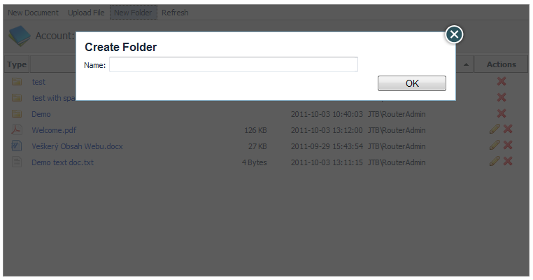
Picture 4: Create folder dialog

SharePoint Containers

DMS Document Library
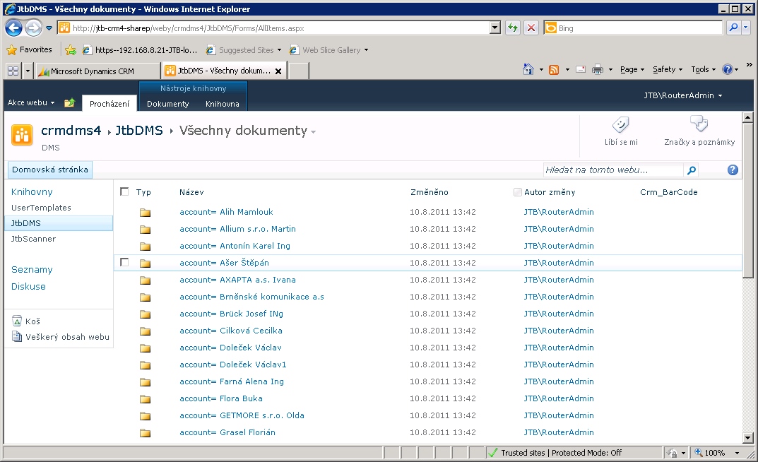
Picture 5: DMS document library – top level
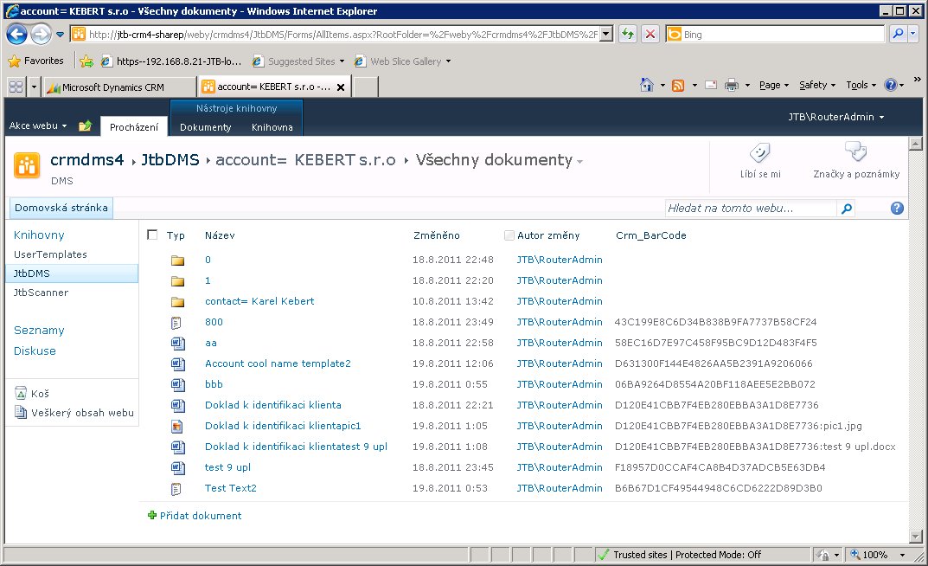
Picture 6: DMS document library – account-entity level
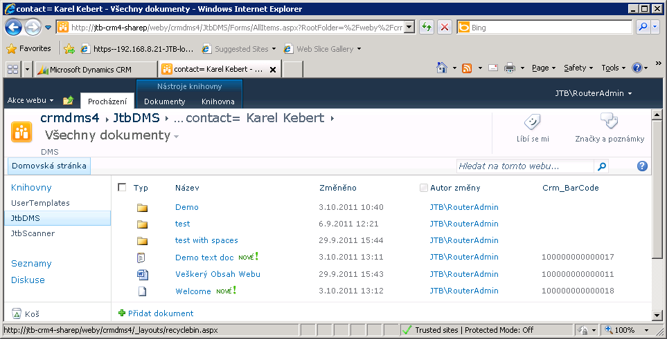
Picture 7: DMS document library – contact-entity level

Template Sink Document Library
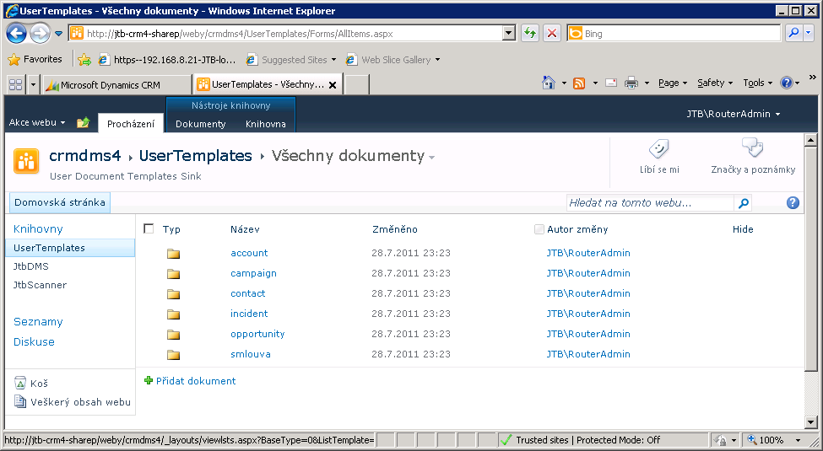
Picture 8: Template sink – top level
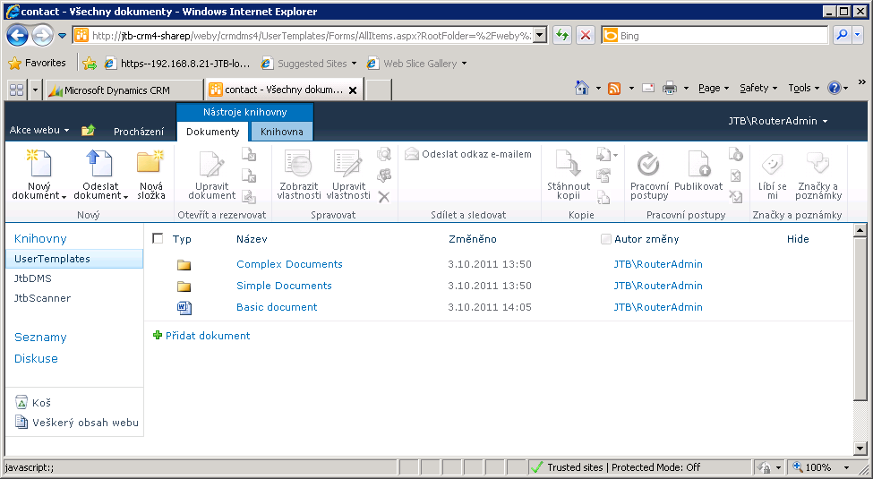
Picture 9: Template sink – entity level

Scanner Sink Document Library
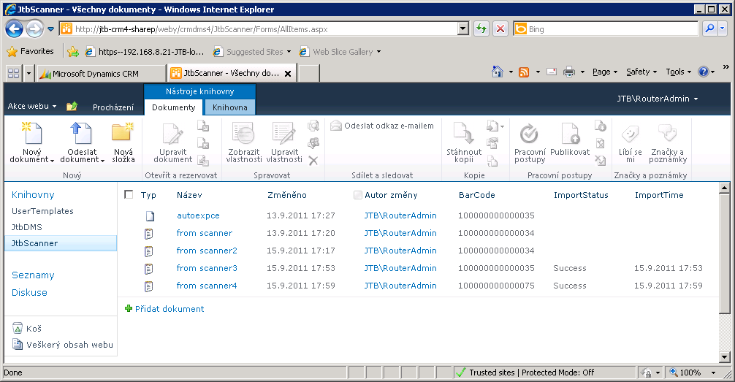
Picture 10: Scanner sink

Templates
Document Templates is the most interesting and powerful feature. It leverages native SharePoint support of Microsoft Word 2007 and uses SharePoint content types as a link and storage for CRM imported data. Template workflow is pretty simple:
- Create Microsoft Word 2007/2010 .DOCX document with content and placeholders
- Upload it to Template sink document library
- Associate template with content type of interest
- Open uploaded document directly from SharePoint and put SharePoint field placeholders

Base Features
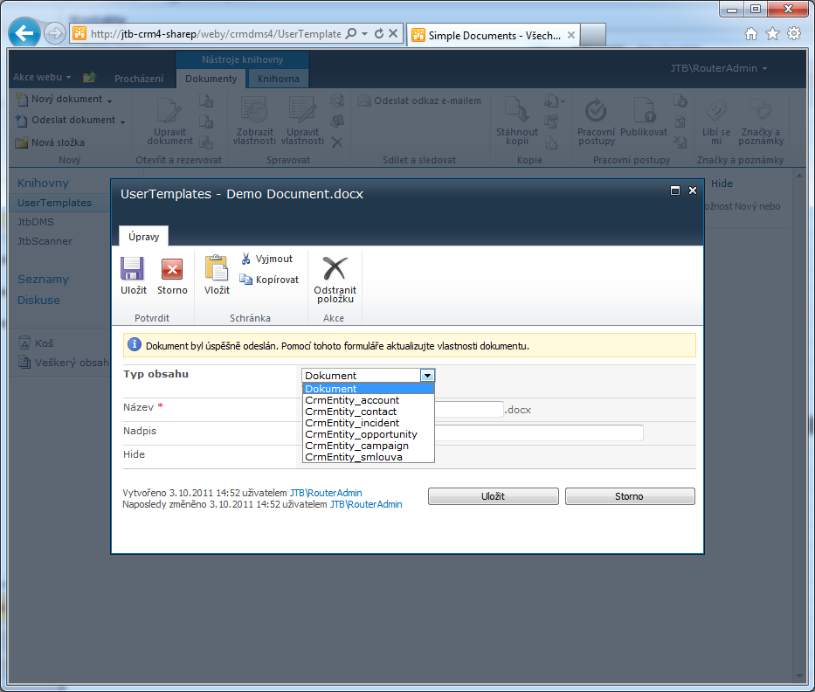
Picture 11: Uploaded template associated with CRM entity

Picture 12: Insertion of SharePoint field placeholders into template document
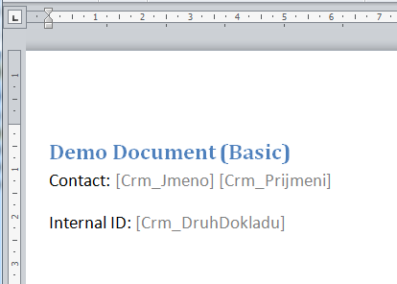
Picture 13: SharePoint fields placeholders
Picture 14: Template file structure is reflected to “Create Document” menu sub-tree

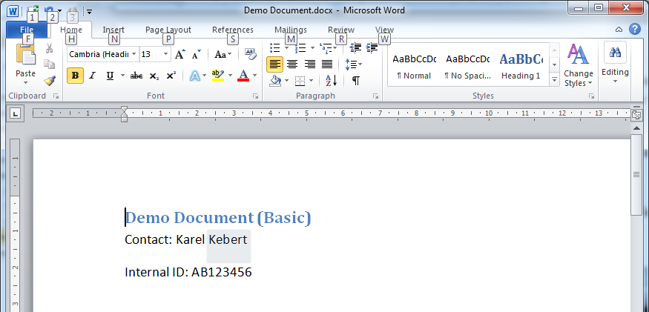
Picture 15: Created document with data imported from CMS

Barcode in Template
Picture 16: Document template with barcode image placeholder
Picture 17: Barcode unique in scope of solution is embedded into document header
Picture 18: Documents imported from scanner are connected to their original document and are shown indented

Conditional Document Blocks
Conditional document blocks allow including or excluding document certain sections depending on data imported from CRM. End document is customized on creation phase automatically. This feature leverages MS Word bookmarking and hidden text features combined with application-evaluated expressions. Blocks which are excluded are not removed but hidden, this way document integrity is not compromised and in case of manual editing authors could change generated documents’ excluded content back to visible if necessary.
Picture 19: Conditional blocks in template

Picture 20: Section with expression evaluated to false is hidden (hidden text is dotted)
Picture 21: Print preview of final document
Picture 22: Print preview of final document for different entity
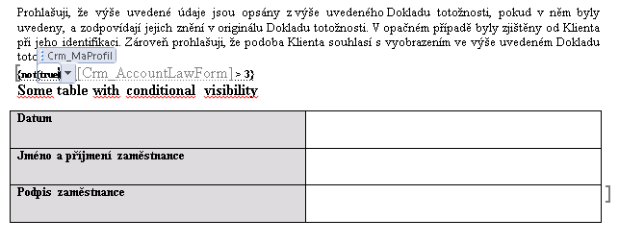
Picture 23: Conditional block with complex expression and table
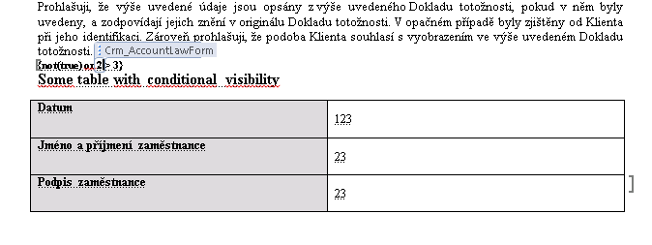
Picture 24: Conditional block in final document is not visible since expression evaluated to false

